STIA1123 Programming 2 Exercise(1.2)

CHUA WEE CHAN 271948

1. Tablet

|  |
| --- |
| <Java class>  TABLET |
| * Brand: String * Operating System : String * Year : Int * Size : String |
| + viewCalender() : void  + unlockScreen(boolean) : void  + playMusic()  + writeNotes() |

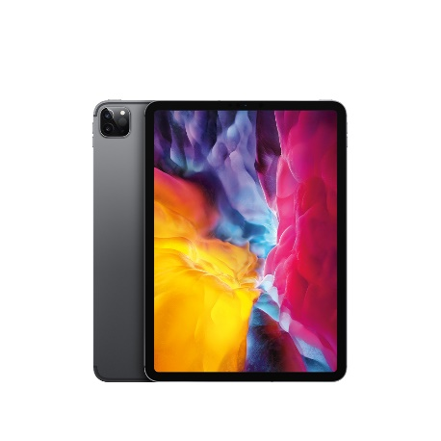

1. Smartphone

|  |
| --- |
| <Java class>  SMARTPHONE |
| * Model : String * Operating System : String * Year : Int * Brand : String |
| + Notification() : String  + Mute(boolean isMute) : void  + takePhoto() : void  + voiceMemo() : void |

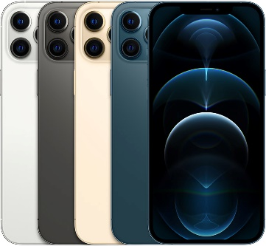

1. Fan

|  |
| --- |
| <Java class>  FAN |
| * Brand : String * Speed : Int * Size : String * Noise : Boolean |
| + turnOn(boolean) : void  + turnOff(boolean) : void  + speedSelect() : void  + swing() : void |

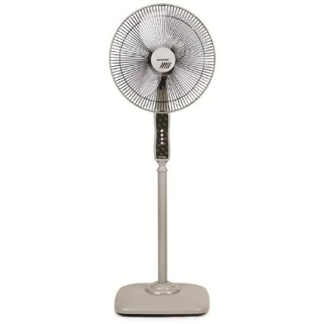

1. Laptop

|  |
| --- |
| <Java class>  LAPTOP |
| * Brand : String * Model : String * Size : String * Num Pad : Boolean |
| + shutDown(boolean) : void  + enter() : void  + openFile() : string  + connectWifi() : boolean |



1. Earphone

|  |
| --- |
| <Java class>  EARPHONE |
| * Brand : String * Model : String * Wireless : Boolean * Mul device : Boolean |
| + connect() : void  + pairing() : void  + playMusic() : string  + volumeUp(int level) : boolean |

